RURITAGE Photo Contest: social media support

Clickable social cards
As an image (card) to your social media posts, you can use the image attached to the email or any other image that you prefer. Furthermore, we recommend creating “clickable cards” with the help of this free website: https://anyimage.io/ A clickable card is an image that works also as a web link. By clicking on such an image, the visitors will be redirected to the page that you have chosen.
Furthermore, by using clickable cards, you will be able to add text in your language to the image.

To use Anyimage.io, follow the steps:
- Register for a free account
- Click “Browse files” and upload an image (the one attached to this email or any other image).
- You will be asked to add:
  - a title. Add it in your language (E.g., translate Join RURITAGE Photo Contest!).
  - a short description. Add it in your language (E.g., translate Do you want to show to the world how special is our area? Take part in the RURITAGE #PhotoContest!).
  - a link to a webpage. Add this link: https://www.ruritage.eu/collaborate-with-us/ruritage-photo-contest/
- Press Finish, copy the link generated by Anyimage.io and paste this link in your social media post instead of an image. You also do not have to add the link to RURITAGE website (as it is already included in the link generated by Anyimage.io).
For further details on how to use Anyimage.io, watch this video.
At the end, you social media post can look similar like this (with the text in your language):
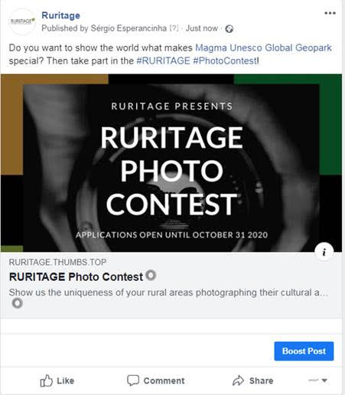

Post examples
Please see below some examples of social media posts about the RURITAGE Photo Contest. Translate them into your language, replace the text in green with the name of your territory, and feel free to adapt them as much as you see the need.

Facebook:

Do you want to show the world what makes our [add the name of your area] special? Then take part in the @RURITAGE #PhotoContest!
RURITAGE brings together #rural areas from all over the world. Many of them are hidden treasures with a unique identity that only locals have been lucky enough to enjoy… until now!
The Photo Contest is a unique opportunity for local communities to showcase the power of their natural and cultural #heritage for rural #regeneration.
Submit your pictures that reflect: #Pilgrimage, #Resilience, #LocalFood, #Landscape, #Migration, and #Art&Festivals.
Learn more about the Photo Contest 🌿🌿👇☺🔝:
(add the link generated with the help of Anyimage.io. If you do not want to use Anyimage.io, add this link:
https://www.ruritage.eu/collaborate-with-us/ruritage-photo-contest/)

Twitter and Instagram:

Do you want to show the world how special our [add the name of your area] is? Take part in the @RURITAGE #PhotoContest! It will help the world discover the #natural and #CulturalHeritage of #rural areas from the local point of view.
Find out more at
(add the link generated with the help of Anyimage.io. If you do not want to use Anyimage.io, add this link:
https://www.ruritage.eu/collaborate-with-us/ruritage-photo-contest/)

LinkedIn:

Use the text of the article attached to the email and add the link generated with the help of Anyimage.io. If you do not want to use Anyimage.io, add this link:
https://www.ruritage.eu/collaborate-with-us/ruritage-photo-contest/

